COMPUTER SCIENCE NEA

Ahmed, Nadir

Contents

**Analysis** 3

Description of the problem 3

Observation of Current System 4

End Users and Acceptable Limitations 6

Limitations 6

Interview Questions 7

Objectives 8

Data Sources and Destinations 10

Existing System 10

Proposed System 10

Data Dictionary 10

Data Flow Diagrams 11

Existing 11

Proposed 11

Entity Relationship Diagram 12

**Design** 13

IPSO Chart 13

System Flowchart 13

Description of Modular Structure of System 14

Login Window 14

Register Window 14

Menu Window 14

Classes Window 14

Set Classes Window 14

Calculator Window 15

Profile Window 15

Edit Details Window 15

Change Password Window 15

Data Dictionary and Validation 16

Data Dictionary 16

Validation 16

Algorithms used 18

Encryption 18

Decryption 18

Validate Username 19

Validate Password 19

Person Prefers 20

Creating a Preference List 20

Stable Marriage Matching Problem 21

Table Relationship Diagram 23

Sample of Planned SQL Queries 24

User Interface Design 25

Initial Design 25

App Jar Design 27

**Testing** 29

Test Table 29

Screenshots 33

**Technical Solution** 57

Overview of Interface 57

Program Code 58

SQL Python Code 58

Main Program Python Code 59

**Evaluation** 83

Were the objectives met? 83

Feedback from the End User 87

Improvements 87

# **Analysis**

## Description of the problem

The problem with fitness clubs is that they will choose members for their sessions based on a “first come, first served” system or through hand picking who they want. Therefore, I am creating a fitness application that is adapted around a club. Usually, applications within this category are focused on the user’s development by allowing the user to input calories through viewing a large database of foods and their nutritional information. As useful as this is, my application will provide similar essentials by allowing the end user to store details and calculate BMI/maintenance calories. However, the focus for my program is to match the members with their preferred class. They will either be chosen or not chosen depending on their BMI. Additionally, the program can allow the fitness club to generate new classes with assigned members through an authorised account.

As mentioned before, the focus for the program is to help the user to determine their optimum class by taking their preferences into consideration. This will be completed by using the “Gale-Shapley Stable Marriage Algorithm”. The authorised account (admin) can select the classes for the following week. This will allow the users of the fitness club to choose which class they want to attend. As a result, this will allow the fitness club to assign a member to a class by implementing the Gale-Shapley Stable Marriage Algorithm. This can be performed as the user’s will have selected their preferences and the classes will have selected their preferences through analysing the user’s details. Users that have a higher BMI than others will require more attention. Therefore, their preferences will be more prioritised.

## Observation of Current System

The current system used by the fitness club is by simply allocating the members depending on who requests which class first. This is inconvenient as members that may need the class more than others will find it difficult to get the classes they want. The club will be setting up classes weekly rather than any other time periods as it is difficult planning ahead. Therefore, the new system will need to be able to set the classes for the week easily as well as be able to allocate the members once everyone has made their choices/preferences.

Considering this problem is focused on one-to-one personal training sessions with the club, it is important to observe the current system that is used to organise the sessions. One system they use which is also used by many clubs is to request a session by filling out a form. Here is an image of the form currently used by the club.

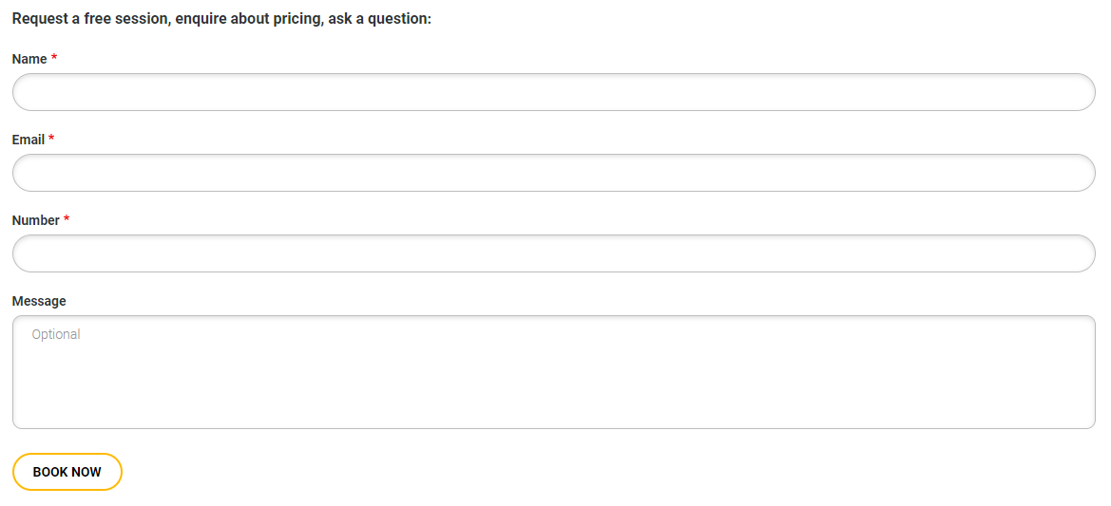

As you can see, members will have to keep filling out a form in order to receive a session. This is tedious as there is no option to log in. It would be ideal if members had the ability to choose a session they want, rather than having to discuss availability times after requesting.

In addition, it would be inconvenient for the club to constantly receive forms with repetitive information that they already have. Therefore, they would need a system that could store everything as well as sort out who has been chosen for the weekly classes. All that would be required from the club is to simply press a button which matches people to the classes.

Here is another example of a system that the fitness club used to organises one-to-one sessions.

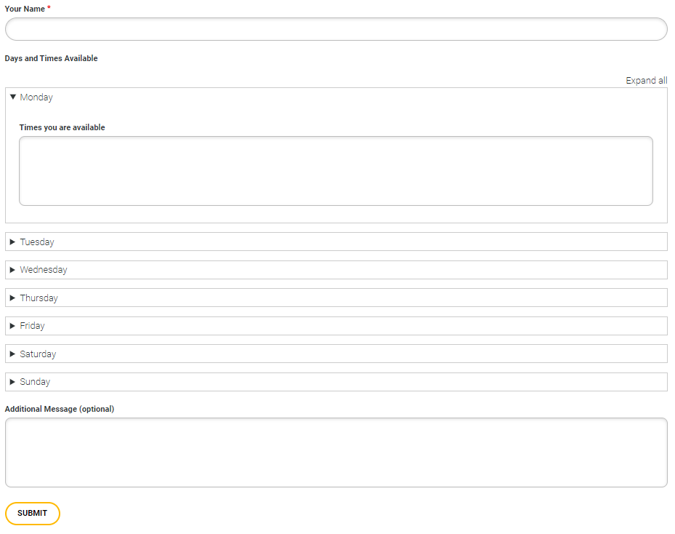

As you can see, there are similar problems from the other system. Members would have to constantly fill out this form in order to receive a session. The main difference of this form is that it has a structure for the seven days of the week. Therefore, members can write down the times that they are available for certain days. This is still inconvenient as timings will have to be discussed with the clubs. It is easier if all the times available were stated so the members can choose which class they like. Finally, the club will have to deal with a lot of forms throughout the week. This would create slow response times with the members as they will have to run classes whilst preparing other classes. If this was completed before the week started, the club would only have to focus on running the classes which will be very useful due to the reduced workload.

## End Users and Acceptable Limitations

The primary end user is Cameron Ritchie, the owner/admin of the fitness club. Considering Cameron is running the fitness club, he will need to be able to set classes every week as well as be able to apply the stable marriage matching algorithm in order to assign each member to a class. Therefore, as the admin, he will have access to the window that can set the classes which other end users will not have the same privilege.

The other end users will be the members of the fitness club. This group of users will be able to write/edit their details, make calculations and choose classes. Once the primary end user has applied the matching algorithm, the members will be able to see who was picked for each class.

### Limitations

* The owner/admin will need to use a computer in order to use the software due to the suitability of Python. Therefore, the owner/admin cannot use their mobile to set classes, despite the convenience of mobile portability.
* Due to my skills and knowledge, I will be focussing on creating a solution to the problem. It will be unnecessary for me to add features that other fitness applications provide such as displaying a large database of different foods.
* The number of classes set each week varies, therefore, the program will set 3 classes a week in order to help me focus on solving the problem. In addition, it will be helpful for me to adapt the solution around 3 classes due to my programming abilities.

## Interview Questions

**How do you currently store class requests?**

When I receive a class request, I check to see if I am available for the member. If I am, I write down the member’s name in my diary, confirm the booking and then I delete the request form in order to clear up my inbox. If I am not available for the member, I contact them through the information that they provided, and we discuss what times we are both available. Once we set a time, I delete their request form.

**What are the main problems that you face when sorting out class requests?**

Firstly, I face pressure as I must respond to new class requests every day. I do not like to keep my members waiting a long time; therefore, I am constantly forced to balance handling enquiries as well as running classes. Secondly, it is time-consuming as I must communicate with every member to either confirm or discuss. Also, I receive requests throughout the day, so it is difficult for me to spend a certain amount of time to just focus on allocating members to classes.

**Which new features would be the most important to you?**

Firstly, it is important for me to have a system in place that could store every one’s requests before I match them to a class. Secondly, if each member had a login that contained their details, I will not have to take notes of their details every time they made a request.

**How do you decide on which members receive a class, if there are duplicate requests?**

Whoever requests first will usually receive the class. If the class requested by someone else has already been allocated, I will discuss another time with them.

**What is usually the focus of these classes?**

When a member arrives to a class, I talk to them about their goals so we can focus on them. I mainly like to work with members that require more attention than others as there will be more room for progress.

**What are the benefits of the current system?**

I will be able to recognise previous members when they make a class request. In addition, I can easily set an ideal time that is convenient for both me and the member as we can discuss.

## Objectives

1. Create a login system
   1. Create a cipher algorithm to encrypt the password
      1. Store the encrypted password using SQL
   2. Provide an option to register
      1. Display the requirements for the password
      2. Create a check which prevents duplicate usernames
      3. Create a check which makes sure the password follows the requirements
      4. Allow the user to see if their password is strong
   3. Provide an option to exit
   4. Make sure the user can log in with the correct details
      1. Check the SQL table to see if the username inputted is valid
      2. Use the cipher algorithm to encrypt the inputted password
         1. Allow the user to continue to the main menu
2. Create a main menu
   1. Provide a classes option
      1. Check if the user is an admin
         1. Give admin option to set up new classes for the following week
         2. Allow the option to save the classes selected
         3. Allow an option to choose who is selected for the classes through implementing the stable marriage algorithm
      2. Check if the user is not the admin
         1. Display the classes for the following week
            1. Allow the user to click on the classes to see who is attending
   2. Provide a calculator option
      1. Allow the user to input age, gender, height, weight and activity rate
         1. Allow the user to calculate their BMI
         2. Allow the user to calculate their maintenance calories
   3. Provide a profile option
      1. Display the username
      2. Display the user’s details
      3. Allow the user to edit their details
         1. Create a window which allows the user to update the details
      4. Allow the user to change their password
         1. Create a window which allows the user to update their password
         2. Create a check to see if the user knows their current password
         3. Create a check to see if the new password meets the requirements
         4. Allow the password to update if all the requirements are met
      5. Allow the user to select their preferred classes
         1. Display all the classes of the week
         2. Allow a select option
         3. Allow a save option
   4. Provide a log out option
3. Create SQL tables
   1. Create a login table that stores username and password
   2. Create a detail table that stores the user’s details
   3. Create a class table which allows the admin to update the weekly classes
   4. Create a user class table which stores user’s preferred classes
   5. Create a match class table which stores the matches

## Data Sources and Destinations

### Existing System

|  |  |  |
| --- | --- | --- |
| **What is it** | **Source** | **Destination** |
| Class Requests | Member fill out a request form | Admin stores the date/time in personal diary |
| Member Details | Member mentions name and contact information in the request form | Admin stores the details in personal diary |

### Proposed System

|  |  |  |
| --- | --- | --- |
| **What is it** | **Source** | **Destination** |
| Class Requests | Member inputs their preferred class in the program | Stored in the user class database table |
| Member Details | Member can write/edit their details in the profile window of the program | Stored in the details database table |
| Classes that the members can choose | Admin will update the classes window weekly | Replace and store in the class database table |
| Login Details | Members will register a unique username and will have a password | Stored in the login database table |
| Classes will have members assigned to them | Admin will apply stable marriage matching algorithm once members have chosen their preferred class | Stored in the matched database table |

## Data Dictionary

|  |  |  |  |
| --- | --- | --- | --- |
| **Field Name** | **Data Type** | **Example** | **Description** |
| Username | String | Nad123 | Every member is allocated a username. The username will be used throughout the program. |
| Password | String | F3g7j4g7k123!2 | The password will be encrypted before it is stored. It will allow the correct user to have access to the program. |
| Age | Integer | 18 | User detail |
| Gender | String | Male | User detail |
| Height | Float | 175 | User detail which will be used to make calculations |
| Weight | Float | 68 | User detail which will be used to make calculations |
| First class | String | 2020-01-01 4:00 | Date and time of the first class |
| Second class | String | 2020-01-05 13:30 | Date and time of the second class |
| Third class | String | 2020-01-10 16:00 | Date and time of the third class |
| Class | String | 2020-01-05 13:30 | This will be assigned alongside the user so it can be displayed in the classes window |

## Data Flow Diagrams



### Existing

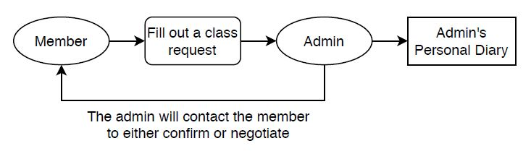

### Proposed

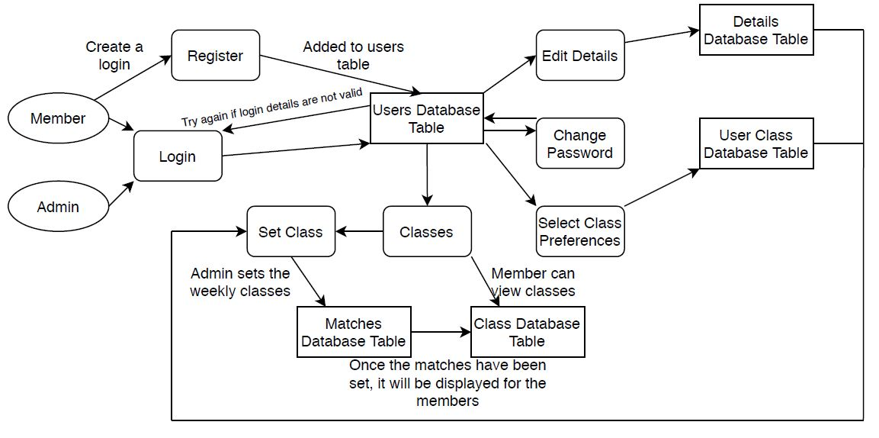

## Entity Relationship Diagram

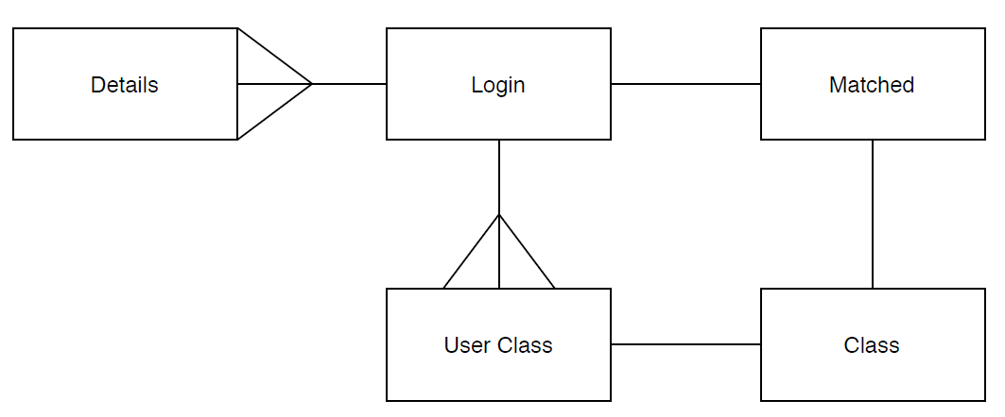

This diagram displays the relationships between the database tables. Firstly, every login will have many different details, however, they will be assigned to one login. Secondly, every login will make many preferences whereas the preferences will be made by one login. Next, every match made will require one login and one class.

# **Design**

## IPSO Chart

|  |  |  |  |
| --- | --- | --- | --- |
| **Inputs** | **Processes** | **Storage** | **Outputs** |
| Username  Password  Set Classes  View Classes  Height  Weight  Gender  Activity Rate  Preferred Classes | Using matching algorithm  Calculating BMI  Calculating maintenance calories  Editing details  Changing password  Inputting preferred classes  Exiting | Users table  Details table  User Class table  Class Table  Matches Table | Displaying the weekly classes  Displaying details |

## System Flowchart

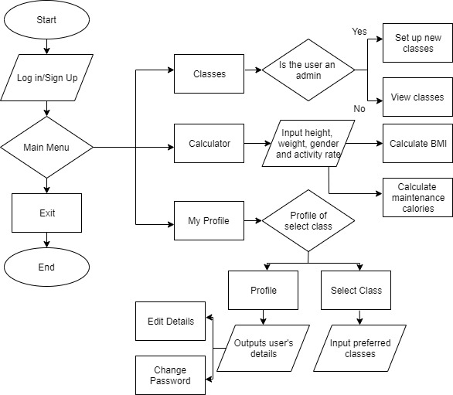

## Description of Modular Structure of System

### Login Window

When the program begins to run, the user will be introduced to the login window. There will be a username input field and a password input field. Below this, there will be three buttons. The first button will say “Sign up”. This would take the user to the register window. The second button will say “Log in”. This will take the input from both fields, in order to check if the login is correct. If it is not, an error box will pop up to notify the user that their input was incorrect. Finally, the third button will say “Exit”. This will quit the program.

### Register Window

If the user presses the “Sign up” button from the login window, the user will be introduced to an information box that informs them of the password requirements. Once the user has pressed “OK”, the register window will show. There will be a create username input field and a create password input field. Below this, there will be a meter bar that will display the strength of the password and two buttons. The first button will say “Check Strength”. This will allow the user to update the strength on the meter bar. The second button will say “Register”. This will register the user, if the username doesn’t already exist and if the password meets the requirements.

### Menu Window

Once the user has logged in, the menu window will show, and the login window will disappear. The user will be introduced to four buttons. The first button will say “Classes”. This will direct the user to the classes window. However, if the user is the admin, they will be directed to the set classes window. The second button will say “Calculator”. This will direct the user to the calculator. The third button will say “My Profile”. This will direct the user to the profile window. Finally, the fourth button will say “Log Out” which will exit the program.

### Classes Window

If the user presses the “Classes” button in the menu window, the user will be introduced to the classes window. There will be three buttons covering the window. All three buttons will display the date and time of each class. If the admin has set the classes, the buttons will direct the user to a new window which will display the attendee of that class.

### Set Classes Window

If the user is the admin, the “Classes” button in the menu window will direct the user to the set classes window. In this window, there will be three boxes. These three boxes will display the date and time of the classes set. Below this, there will be a date input box, a time input box and three buttons. Once the date and time has been selected, the select button can be used to set the classes for the week. The save button can be used to save the weekly classes, once they have been selected. Finally, the generate button will use the matching algorithm to match the classes to the members that has chosen their preferences.

### Calculator Window

If the user presses the “Calculator” button in the menu window, the user will be introduced to the calculator window. The window will be separated into two frames, side by side. The right frame will have five input fields which will request age, gender, height, weight and activity rate. The left frame will have two buttons, “Calculate BMI” and “Calculate Calories”. They will be used to make calculations, once the input fields have been filled in.

### Profile Window

If the user presses the “My Profile” button in the menu window, the user will be introduced to the profile window. This window will be separated into two frames, side by side. The left frame will have two buttons, “My Profile” and “Select Class”. If these buttons are pressed, the right frame will change. If the “My Profile” button is selected, the right frame will display the user’s username, their details and two other buttons that say, “Edit Details” and “Change Password”. If the “Select Class” button is selected, the right frame will display three boxes, a list box and two buttons. The three boxes will display the user’s preferred classes once they have been selected and saved. The list box will display the classes the user can select. Finally, the two buttons say, “Select” and “Save”. If the user presses “Select”, the box will display the highlighted class in the list box. If the user presses “Save”, it will save the user’s preferences.

### Edit Details Window

If the user presses the “Edit Details” button in the profile window, the user will be introduced to the edit details window. In this window, there will be four input fields and a button. The four input fields require the user to input their gender, age, height and weight. The button says, “Update”. This will update the user’s details, if the input fields have been filled in.

### Change Password Window

If the user presses the “Change Password” button in the profile window, the user will be introduced to the change password window. In this window, there will be two input fields and a button. The two input fields require the user to input their existing password and a new password. The button says, “Update”. This will update the user’s password, if their existing password matches the input.

## Data Dictionary and Validation

### Data Dictionary

|  |  |  |  |
| --- | --- | --- | --- |
| **Field Name** | **Data Type** | **Example** | **Description** |
| Username | String | Nad123 | Every member is allocated a username. The username will be used throughout the program. |
| Password | String | F3g7j4g7k123!2 | The password will be encrypted before it is stored. It will allow the correct user to have access to the program. |
| Age | Integer | 18 | User detail |
| Gender | String | Male | User detail |
| Height | Float | 175 | User detail which will be used to make calculations |
| Weight | Float | 68 | User detail which will be used to make calculations |
| First class | String | 2020-01-01 4:00 | Date and time of the first class |
| Second class | String | 2020-01-05 13:30 | Date and time of the second class |
| Third class | String | 2020-01-10 16:00 | Date and time of the third class |
| Class | String | 2020-01-05 13:30 | This will be assigned alongside the user so it can be displayed in the classes window |

### Validation

|  |  |  |  |  |  |
| --- | --- | --- | --- | --- | --- |
| **Field Name** | **Validation Checks** | **Description** | **Error Message** | **Data** | **Caught** |
| Create Username | Validate Username Function | Checks if the username already exists or not | Username already exists | Nad123 | Yes |
| Create Password | Validate Password Function | Checks if the password meets the requirements | Password does not meet requirements | A1 | Yes |
| First Class/Second Class/Third Class | Date Picker | Forces user to input a valid date |  | 2020/01/02 | No |
| Log In | Try exception and if statement | Checks to see if the username or password inputted is correct | Wrong username or password | Nod | Yes |
| Change Password | If statement | Checks to see if the existing password inputted is correct | Existing password is incorrect | A1 | Yes |
| Change Password | If statement | Checks to see if the new password meets the requirements | New password has failed to meet requirements | A1 | Yes |
| Select preferences | If statement | Checks to see if all the preferences were selected | Not all preferences were selected | 2020/01/02  2020/01/05 | Yes |
| Select Classes | If statement | Checks to see if the classes were set for the week | Not all the classes were selected | 2020/01/02  2020/01/05 | Yes |

## Algorithms used

### Encryption

In this program, I implemented encryption by constructing my own algorithm. The algorithm is used when logging in, signing up and updating password. Firstly, the algorithm converts every character of the plaintext password into its Unicode code, then adds the length of the plaintext to the code of each character. Now, the new Unicode code of each character is converted back. This will form a different string than the plaintext password. Next, an encrypted password will be developed by adding the new character alongside a random integer.

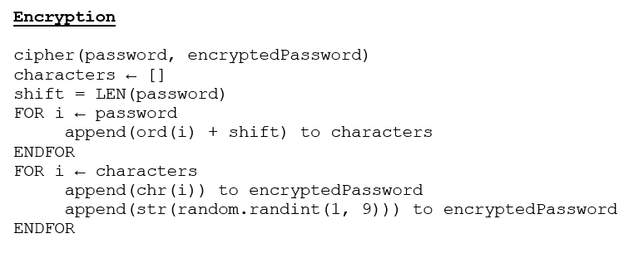

### Decryption

The decryption algorithm that I implemented in this program is mainly used for signing in. The algorithm will need to decrypt the encrypted password that will be obtained from the users SQL table.

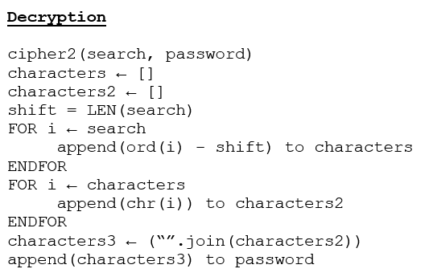

### Validate Username

This algorithm is used to check whether the username that the user had inputted is valid. This is performed by searching through the users SQL table. If the username already exists, it will return a false value. If the username is less than one character, it will return a false value. Therefore, it will not allow the user to create a login with the name or to login. However, if the username does not already exist, the user can continue to complete the registration or login. For a program of this size, it is appropriate to use this method of obtaining all the usernames and appending them to a list as there won’t be a very large number of members.

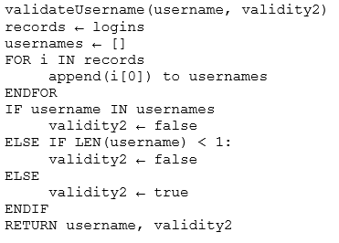

### Validate Password

This algorithm is used to check whether the password inputted meets the requirements. This is performed by checking if it meets every condition highlighted. If it does not meet the condition, the loop will break, therefore returning a false value which indicates that the password is not a valid input.

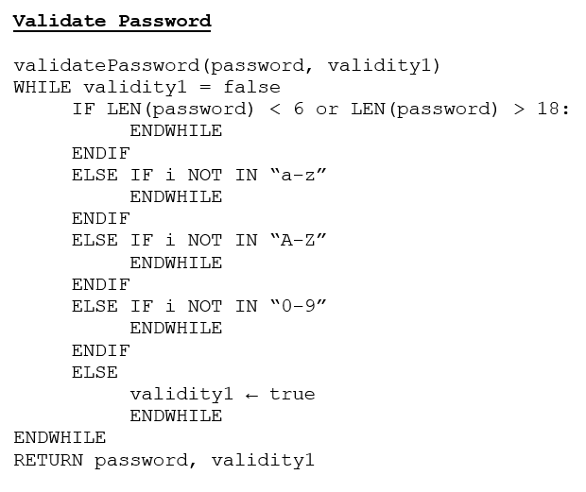

### Person Prefers

This function is used inside the matching stable marriage matching algorithm. It will return a true value, if the person prefers the new proposed class over their current class. If the person does not, the class they have will remain.

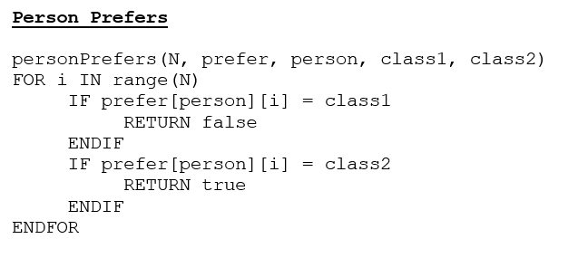

### Creating a Preference List

This algorithm is used to create a preference list that will be passed onto the stable marriage matching algorithm. It needs to create a preference list for the classes by obtaining the BMI of every member that has chosen classes. Then, the member with the largest BMI will be prioritised. Next, it will obtain the preference list from the members that were chosen. Finally, a new list will contain the position of each members and class preferences as this will be needed for the matching algorithm.

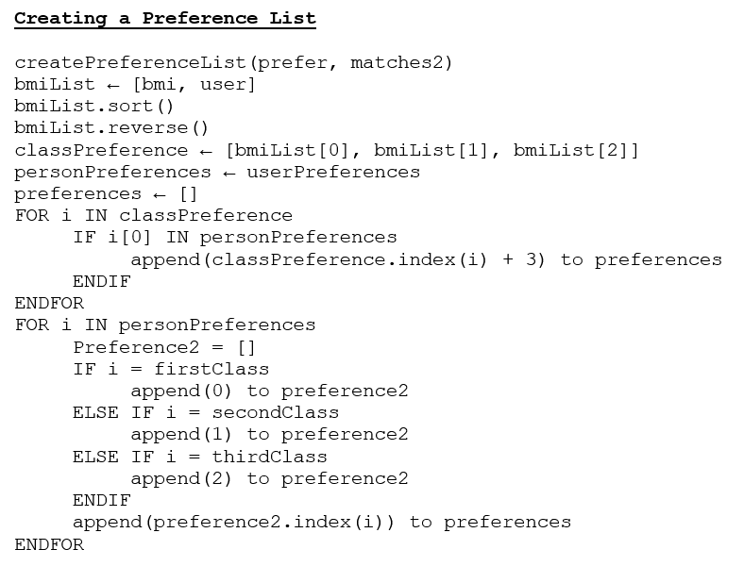

### Stable Marriage Matching Problem

This algorithm is used to match the members chosen with the classes they prefer. Once the preference list has been created from the previous algorithm, it will proceed to match everyone. First, it would loop around every member that does not have a class assigned to them. While this loop continues, it would match the class with a member that they prefer. If the member does not already have a class assigned to them or prefers the class that is requesting them, they will match with that class and will reject the class that they were assigned to. This iteration will continue until everyone is matched. By the end, every match will be stable. After this occurs, the matches will be stored on the matched database table and then be displayed onto the classes window for the members to view.

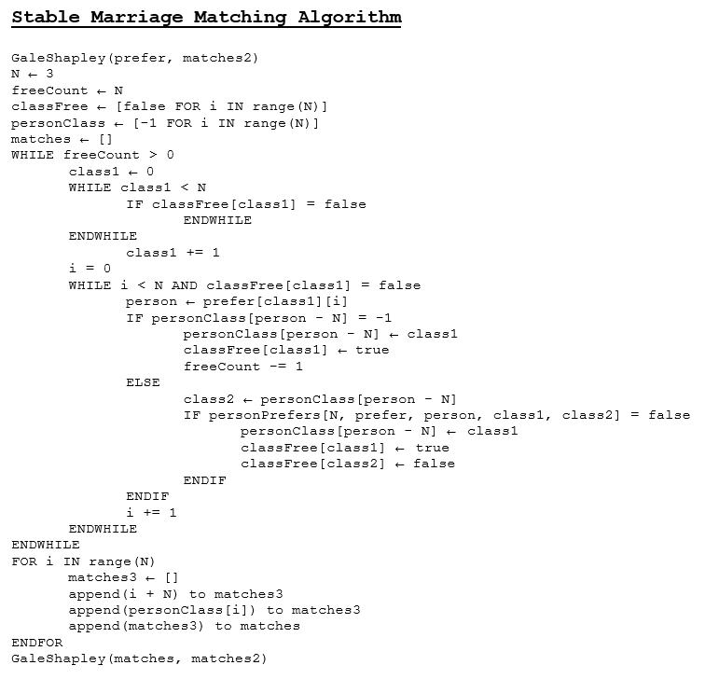

## Table Relationship Diagram

This diagram illustrates the relationships between the tables in the proposed system.

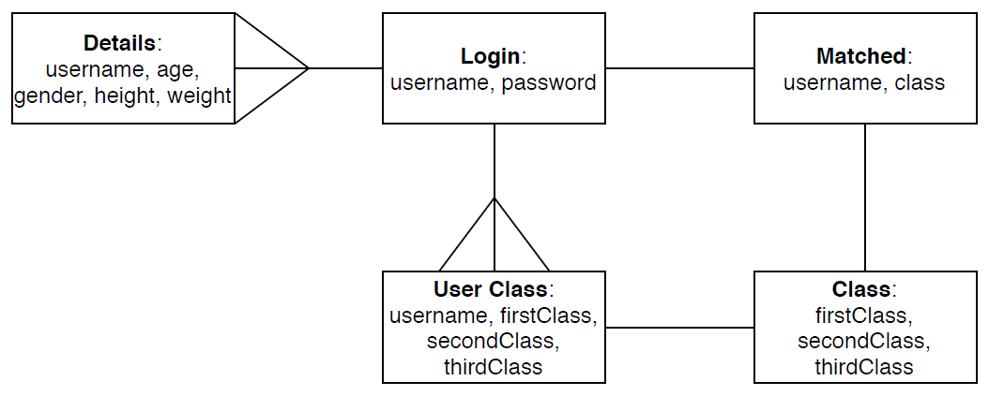

## Sample of Planned SQL Queries

|  |
| --- |
| **Searching to see if the inputted username exists** |
| SELECT password  FROM logins  WHERE username = ? |

|  |
| --- |
| **Registering a new username and password** |
| INSERT INTO logins  VALUES username, password |

|  |
| --- |
| **Updating a member’s details** |
| DELETE FROM details  WHERE username = ?;  INSERT INTO details  VALUES username, age, gender, height, weight |

|  |
| --- |
| **Setting a member’s preferences** |
| INSERT INTO user class  VALUES username, first class, second class, third class |

|  |
| --- |
| **Admin setting new classes for the week** |
| INSERT INTO class  VALUES first class, second class, third class |

|  |
| --- |
| **Setting up the matches made for the classes** |
| INSERT INTO matches  VALUES username, class |

|  |
| --- |
| **Displaying details in the profile window for a member** |
| SELECT *  FROM details  WHERE username = ? |

## User Interface Design

### Initial Design

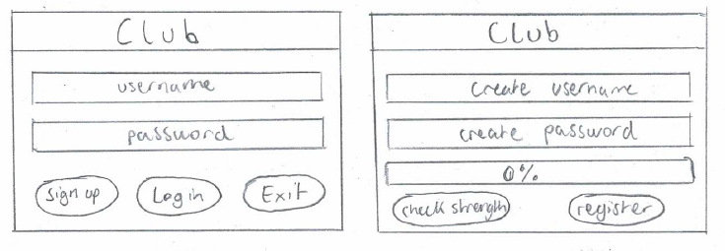

This is the initial design of the login and register window. This is very simple and easy to follow. The user can either log in or use the sign-up button to go to the register window. Here, there is a strength bar which will notify the user on how strong their password is.

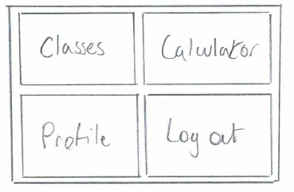

This is a simple sketch of the main menu which presents the main functions of the program. It will be constructed by buttons.

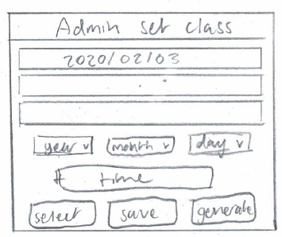 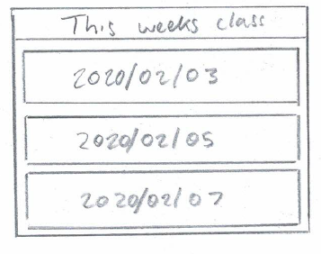

Here is a sketch of the two windows that can pop up if you click on the classes button in the main menu. If you are the admin, the admin set class window will pop up. If you are a member, the weeks class window will pop up. The admin set class window has three boxes to display the weekly classes that will be set. Then the date and time input fields are set to avoid any typos as they force a valid input through their structure. In the weeks class window, the member will be presented with three dates. If the classes have been set, the member will be able to view who has been chosen.

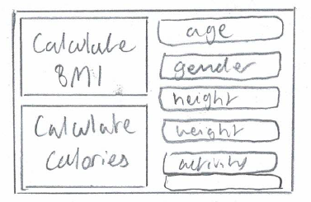

This is a sketch of the calculator window. The user will be able to input the following fields on the right, then they will be able to use the buttons on the left in order to display the following calculations.

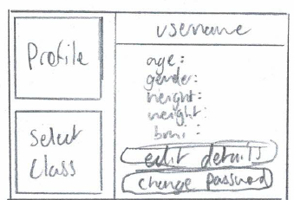 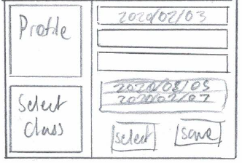

Here is the initial design of the profile window. The two buttons on the left side of the window will change the right side. If the profile button is selected, the right side will display the user’s username, their details and the options to edit the details or change password. If the select class button is selected, the user will be presented with three boxes, a list and two buttons. Here, they will be able to choose their preferences and then be able to save their preferences for the admin to apply the matching algorithm.

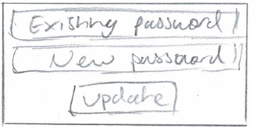 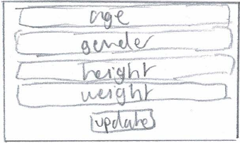

These two sketches display the windows that will open, if the user presses the two buttons on the profile selection of the profile window. They are very simple and they allow the user to either change their password or to edit their details.

### App Jar Design

For me to construct this program, I will use a cross-platform, open source Python library called app jar. This will assist me with creating the graphical user interface that I designed.

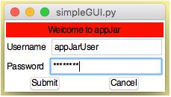

Here is a simple log in page that can be made using this library. This will assist me with developing most of this program as I will need to use a lot of input fields and buttons.

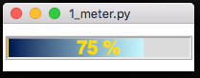

This meter bar that can be made using this library will be required in this program as I will have a password strength feature in the register window.

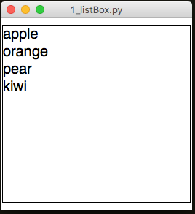

Here is a list box that will be required in the program. This will help me as the user and admin need to select classes. If the user highlights an item in this list box, they can use buttons to manipulate the item.

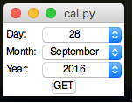

This is a date picker feature within the app jar library. This will help the admin to select dates for the week. Having this feature will help avoid issues as this will consistently produce the correct format for the date.

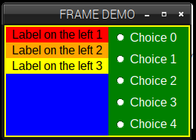

This is a simple frame demo. This will assist me as I will be able to incorporate this, especially in the profile window as it will be separated into two frames.

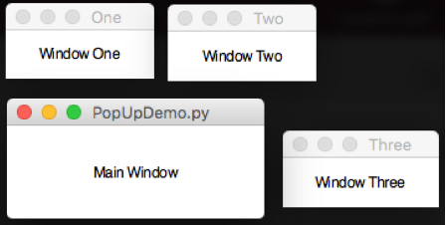

Finally, this library allows me to create and launch multiple windows. This will be useful as my program will need to display a lot of functions using the windows.

# **Testing**

The tests that will be conducted on the program will ensure that all the core functions are working correctly. The testing will involve the different data types in order to see if the program can withstand all inputs it can receive. After this test table, I will record screenshots to show evidence of each test.

## Test Table

|  |  |  |  |  |
| --- | --- | --- | --- | --- |
| **Test Number** | **Description** | **Data Type** | **Expected Result** | **Pass/Fail** |
| 1 | The menu window should not appear if the username or password is incorrect. | Erroneous | An error box will pop up to notify the user that the inputted details is wrong. | Pass |
| 2 | The menu window should appear if the username or password is correct and the user presses the log in button. | Typical | The main menu will show, and the login window will disappear. | Pass |
| 3 | An information box will pop up and notify the user about the password requirements, if you press the sign-up button. | Typical | The information box will pop up about password requirements. | Pass |
| 4 | The password meter should display the strength of the inputted password after pressing the check strength button. | Typical | The meter will display a percentage as well a colour that represents the strength (red for weak, orange for medium and green for strong). | Pass |
| 5 | Will not register, if the created username already exists. | Erroneous | Error box will notify the user about the existing username. | Pass |
| 6 | Will not register, if the created username has no input. | Extreme | Error box will notify the user about the invalid input. | Pass |
| 7 | Will not register, if the created password does not meet the requirements. | Erroneous | Error box will notify the user about the created password not meeting the requirements. | Pass |
| 8 | The program will no longer run, if the user presses the exit button. | Typical | Program will close. | Pass |
| 9 | None of the windows in the main menu will show, if the user clicks in the middle in between the four buttons. | Extreme | Nothing will happen. | Pass |
| 10 | The classes window will show, if the user presses the classes button in the main menu. | Typical | Classes window will show. | Pass |
| 11 | A window that displays the attendee of the first class will show, when the first-class button is pressed. | Typical | The new window will display the attendee. | Pass |
| 12 | A window that displays the attendee of the second class will show, when the second-class button is pressed. | Typical | The new window will display the attendee. | Pass |
| 13 | A window that displays the attendee of the third class will show, when the third- class button is pressed. | Typical | The new window will display the attendee. | Pass |
| 14 | The calculator window will show, if the user presses the calculator button in the main menu. | Typical | Calculator window will show. | Pass |
| 15 | The age input field should only accept integer values. | Erroneous | The calculations will not be displayed. | Pass |
| 16 | The gender option box should display two options. | Typical | Two options will be displayed. | Pass |
| 17 | The height input field should not accept string data. | Erroneous | The calculations will not be displayed. | Pass |
| 18 | The weight input field should not accept string data. | Erroneous | The calculations will not be displayed. | Pass |
| 19 | The activity rate option box should display four options. | Typical | Four options will be displayed. | Pass |
| 20 | The calculate BMI button should display the BMI, if all the input fields have been inputted correctly. | Typical | BMI will be displayed. | Pass |
| 21 | The calculate calories button should display the maintenance calories, if all the input fields have been inputted correctly. | Typical | Maintenance calories will be displayed. | Pass |
| 22 | The profile window will show, if the user presses the profile button in the main menu. | Typical | Profile window will show. | Pass |
| 23 | The user’s details will be displayed, if they have already been set. | Typical | User’s details will show. | Pass |
| 24 | The user’s details will display empty details, if they have not set it up. | Typical | Will display empty brackets. | Pass |
| 25 | The edit details window will show, if the user presses the edit details button in the profile window. | Typical | Edit details window will show. | Pass |
| 26 | The details will not update, if the input fields are incorrect. | Erroneous | Error box will notify the user of the incorrect input. | Pass |
| 27 | The details will update, if the input fields are correct. | Typical | Information box will pop up to confirm the update. | Pass |
| 28 | The change password window will show, if the user presses the change password button in the profile window. | Typical | Change password window will show. | Pass |
| 29 | The password will not update for the user in the change password window, if the existing password inputted does not actually matching the existing password. | Erroneous | Error box will notify the user about the incorrect input. | Pass |
| 30 | The password will not update for the user in the change password window, if the new password inputted does not meet the requirements. | Erroneous | Error box will notify the user about not meeting the password requirements. | Pass |
| 31 | The password will update for the user in the change password window, if the existing password matches and the new password meets the requirements. | Typical | Password will change and the login can no longer be entered with the old password. | Pass |
| 32 | The right frame inside the profile window will change, if the select class button is selected. | Typical | Right frame will change to the select class frame. | Pass |
| 33 | The three boxes will display the user’s preferences, if they have already been chosen. | Typical | Boxes will display which classes they prefer. | Pass |
| 34 | The list will display the classes for the week, regardless of whether the preferences have already been chosen as this will allow the user to make any changes if they want. | Typical | List will display the classes for the week. | Pass |
| 35 | The select button in the select class frame will add the highlighted list item to the corresponding box. | Typical | Selected class will be added to the box. | Pass |
| 36 | The save button will save and store the selected classes. | Typical | Information box will pop up to clarify that it has saved. | Pass |
| 37 | The preferences will not save, if not all the classes were selected. | Erroneous | Error box will show to notify the user that not all preferences were selected. | Pass |
| 38 | The admin set class window will show, if the user is the admin and has pressed the classes button in the main menu. | Typical | Admin set class window will show. | Pass |
| 39 | The admin set class window will display three boxes which will show the week’s class. | Typical | Three boxes will display the week’s class. | Pass |
| 40 | The admin set class window will have a date picker tool which will allow the admin to pick out a date. | Typical | The tool will can represent a date. | Pass |
| 41 | The admin set class window will have a time input field. | Typical | Admin can represent time in any format they desire. | Pass |
| 42 | The admin set class window will have a select button which will place the selected class in the corresponding box. | Typical | Box will represent the selected class. | Pass |
| 43 | The admin set class window will have a save button which will store the classes set by the admin. | Typical | The classes selected will be represented, even if the program has restarted. | Pass |
| 44 | The admin will not be able to save without selecting all the classes for the week. | Erroneous | Error box will show to notify the admin that not all the classes have been selected for the week. | Pass |
| 45 | The generate button in the admin set class window will apply the stable marriage matching algorithm, if enough people have selected the preferences. | Typical | Information box will pop up to clarify that the classes have been generated. | Pass |
| 46 | The generate button will not match the classes and members, if enough members have not selected their preferences. | Erroneous | Error box will show to notify the admin that enough people have not selected their preferences. | Pass |

## Screenshots

|  |  |
| --- | --- |
| **Test Number** | **Screenshot** |
| 1 | In this test, I inputted a username that does not exist. As a result, an error box had popped up to notify me that the username or password is incorrect. If the username was valid, the same error box would show. The reason why the error box is used for both cases it to avoid giving clues to any unauthorised people attempting to get into someone else’s account. |
| 2 | In the first screenshot, I inputted a username and password that is valid and has been registered. As a result, the login window disappeared, and the main menu window appeared. |
| 3 | From pressing the sign-up button from the login window, the sign-up window had opened. Here an information box pops up to inform the user on what requirements must be met for the created password. |
| 4 | After typing in a password that meets the requirements, the check strength button allows me to see if the created password is strong. |
| 5 | In this test, I had inputted a username has already been created, therefore, this error box shows up to inform me that it already exists. |
| 6 | In this test, I did not input anything for the created username field. As a result, the same error box from the previous test shows up to inform me that it is not a valid input. |
| 7 | In this test, I had inputted three different passwords that do not meet the requirements. As you can see from the first one, it is less than 8 characters and does not include any numbers. The second one does not contain any uppercase characters or numbers. Finally, the third one is longer than 18 characters, despite meeting the other requirements. The user will not be able to register until the created password meets the requirements. |
| 8 | If I press the exit button, the program would close. |
| 9 | If I clicked in between the four buttons, nothing would happen. |
| 10 | The classes window will show if I press the classes button. |
| 11 | The first-class window opens if I press the first button on the classes window. |
| 12 | The second-class window opens if I press the second button on the classes window. |
| 13 | The third-class window opens if I press the third button on the classes window. |
| 14 | The calculator window opens if I press the calculator button in the main menu window. |
| 15 | If I press the either the calculate BMI button or the calculate calories button, the display on the bottom right will not show the result of the calculation due to the incorrect input in the age input field. The user must input an integer in this case in order to display a calculation. |
| 16 | If I click on the gender option box, two options will drop down. |
| 17 | In this test, I inputted a string into the height input field. As a result, the bottom right display does not show the calculation. |
| 18 | In this test, I inputted a string into the weight input field. As a result, the bottom right display does not show the calculation. |
| 19 | If I press the activity rate option box, four options will drop down. |
| 20 | As you can see from the screenshot, all the input fields are in the correct format. Therefore, if I press the calculate BMI button, the display on the bottom right will show the calculation. |
| 21 | As you can see from the screenshot, all the input fields are in the correct format. Therefore, if I press the calculate calories button, the display on the bottom right will show the calculation. |
| 22 | If I press the profile button in the main menu, the profile window will open. |
| 23 | As you can see, the profile frame on the right displays the details of the user. |
| 24 | As you can see, the profile frame on the right displays empty details on this newly created user as the details have not been set. In order for the user to set them, they will need to press the edit details button. |
| 25 | If I press the edit details button in the profile window, the edit details window will show. |
| 26 | As you can see, the height input field has been typed in incorrectly. The field does not expect a string. Therefore, an error box has popped up to notify the user that there is an incorrect input. |
| 27 | In this test, I had inputted the details correct in the edit details window. After doing so, I pressed the update button. An information box will pop up to clarify that the details have been updated. Then, you will be able to see that the details part of the profile window has been filled. |
| 28 | If I press the change password button in the profile window, the change password window will show. |
| 29 | If I press update and the existing password field has been inputted incorrectly, this error box will pop up to notify the user that the existing password is incorrect. You can also see that the input in the existing password field does not meet the password requirements, therefore it must mean that it does not match the existing password. |
| 30 | In this test, I had inputted the existing password correctly, however the new password inputted does not meet the password requirements. Therefore, this error box pops up to notify the user that the password has failed to meet the requirements. |
| 31 | After the password has been updated, you can no longer log in with the previous password. As you can see, the password input is now longer due to the new change. This new password can only be used to log in. |
| 32 | If the select class button is pressed in the profile window, the right frame will change from the details frame to this frame. |
| 33 | The three boxes will display the user’s preferences. In this case, they have already been selected and saved. Therefore, if I exit and go back to this page, it will continue to show the classes selected. |
| 34 | The list remains here as it will allow the user to make any changes before the matching algorithm is implemented. |
| 35 | As you can see, when an item in the list box is highlighted, the select button can be used to make the user’s preferences. The first item selected will go in the first box, the second item selected will go in the second box and the third item selected will go in the third box. |
| 36 | In this test, I have pressed the save button in order to save/store the user’s preferences. After I had done so, I left the window and returned to it to show that the preferences have remained. In addition, the list remains, if the user would like to make any changes. |
| 37 | As you can see, I did not fill in all the options. Therefore, an error box pops up to say that not all the preferences were selected. |
| 38 | If the admin logs in, the classes button in the main menu will direct the admin to the admin class window. |
| 39 | The three boxes in this window shows the classes that have been set for the week. |
| 40 | As you can see, the date picker tool provides the user with the option to select a date. |
| 41 | The admin can use the time input field to input the time in any format they want. This can be done because the date and time will be stored together as a string. |
| 42 | As you can see, the admin has not filled in all the classes |
| 43 | If the admin presses save, the classes will be set for the week and they will show in the profile window for every member. |
| 44 | As you can see, not all the classes were selected for the week, therefore, an error box will pop up and say that not all the classes were selected. |
| 45 | As you can see, enough people have made preferences. Therefore, the admin will be able to press the generate button in order to match the classes with a member. |
| 46 | As you can see, the new classes have just been set and not enough members have made their preferences. Therefore, the classes and members will not be matched until there is enough people. |

# **Technical Solution**

## Overview of Interface

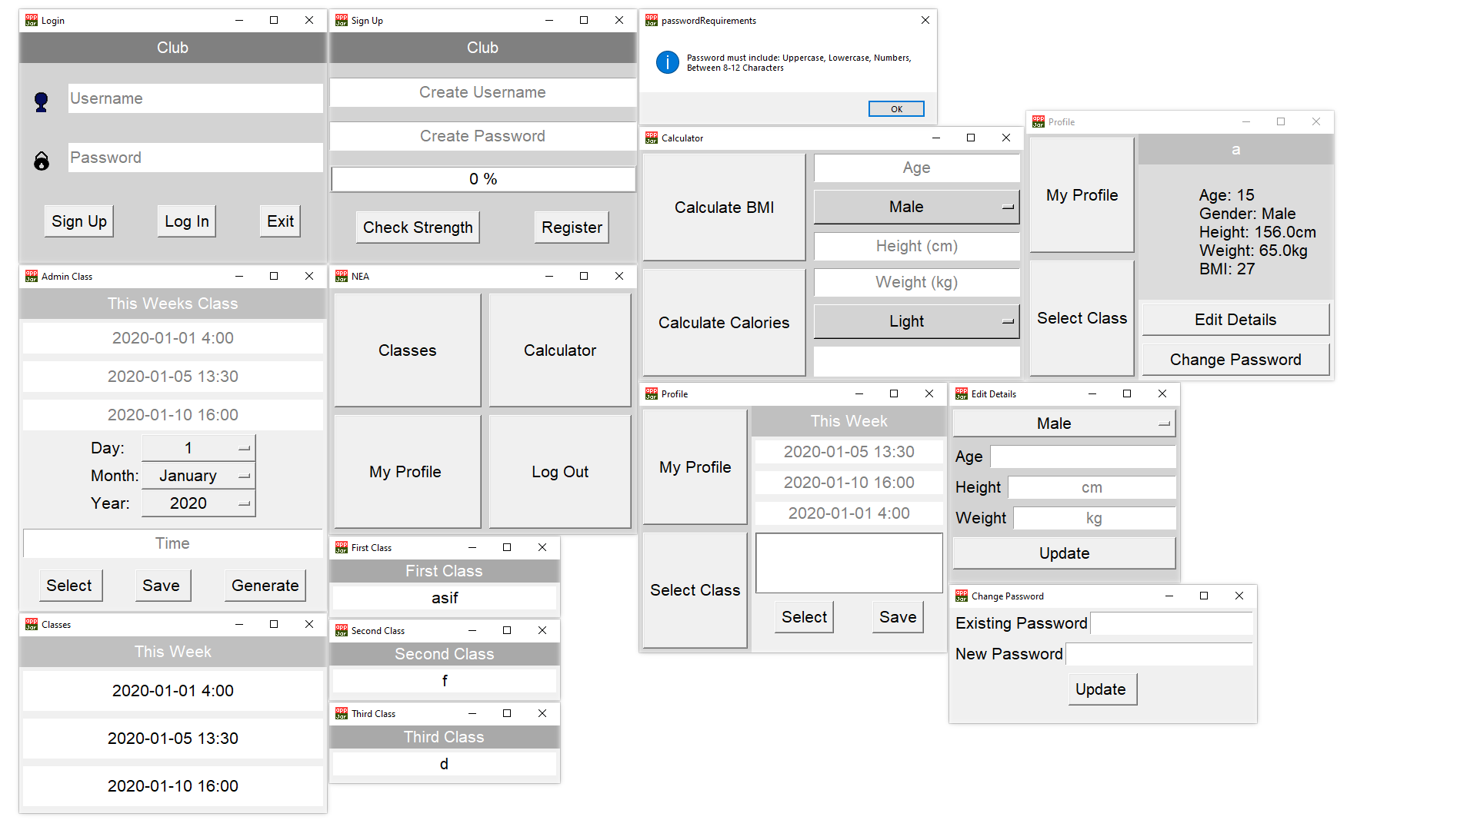

## Program Code

The program code will be displayed in sections and in order. The images of the code that have numbers at the top right indicate that they are from the same section.

### SQL Python Code

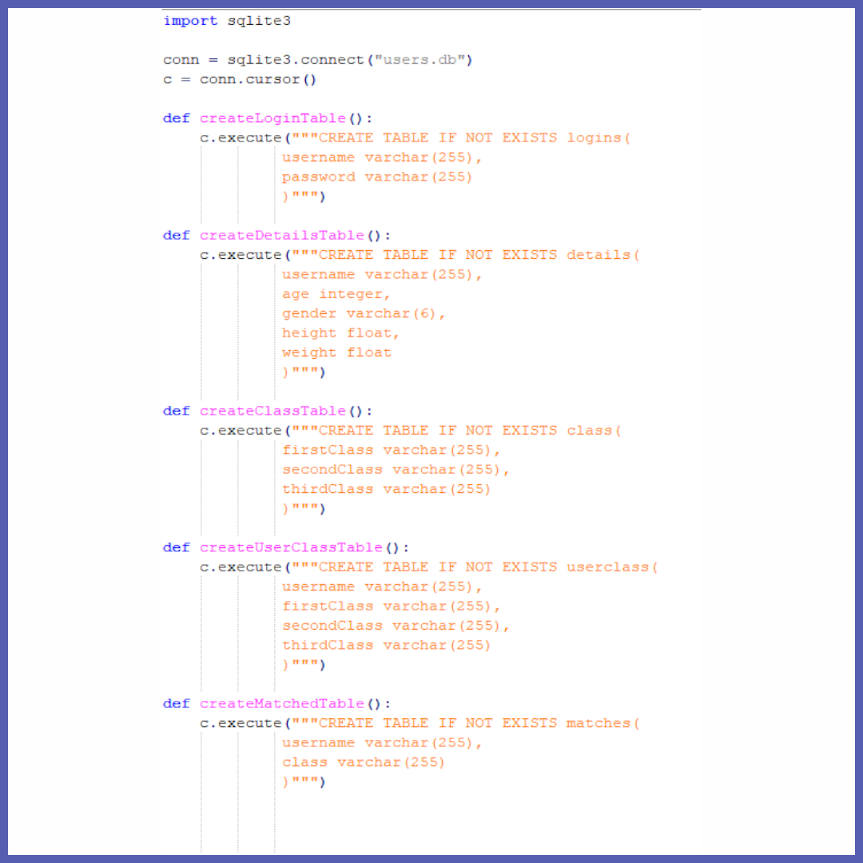

### Main Program Python Code

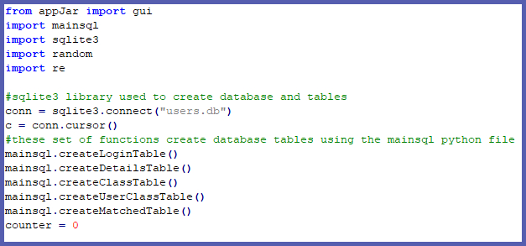

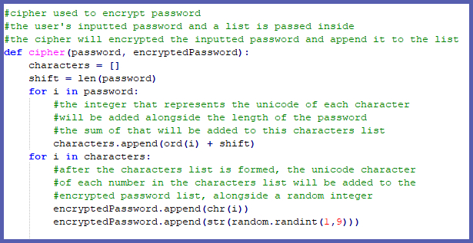

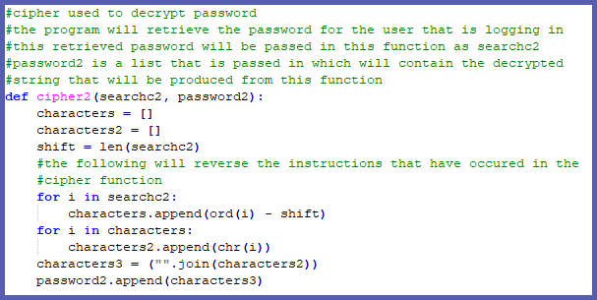

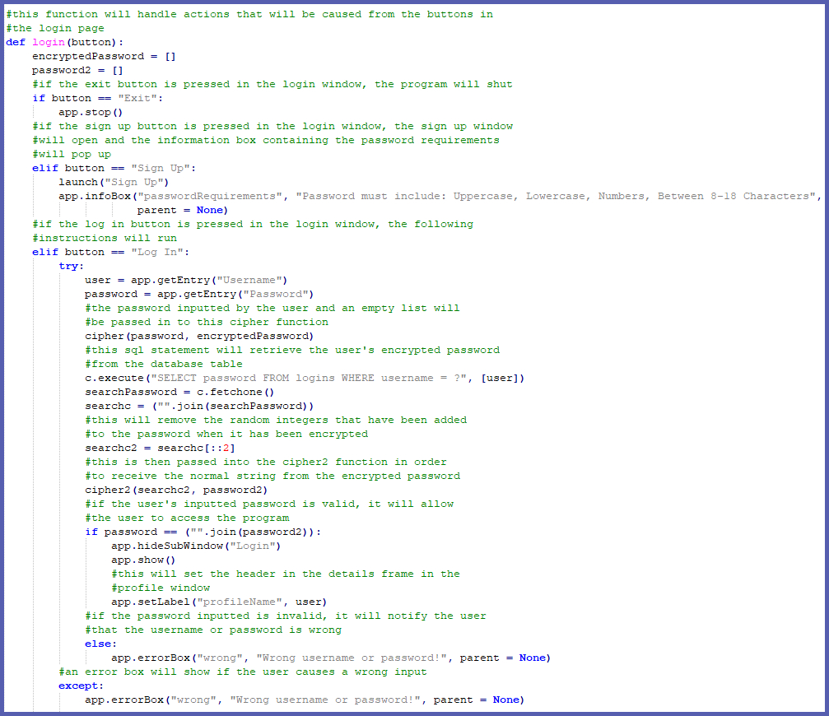

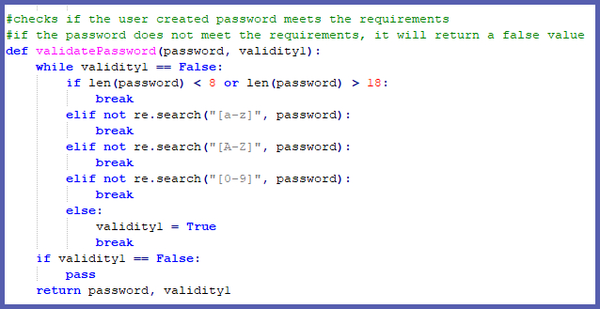

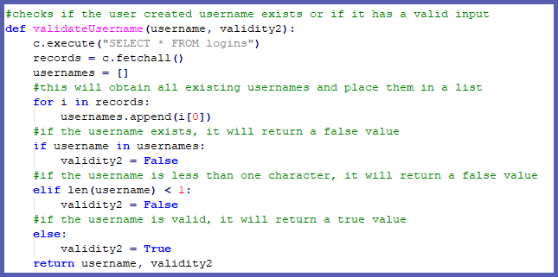

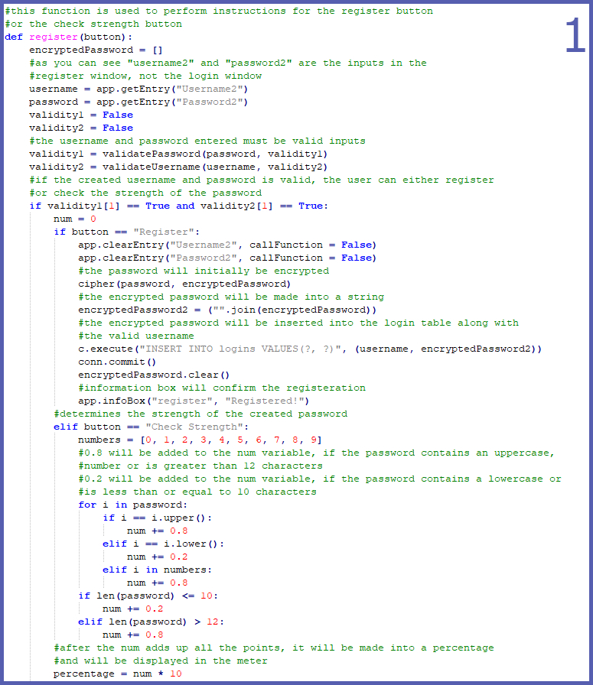

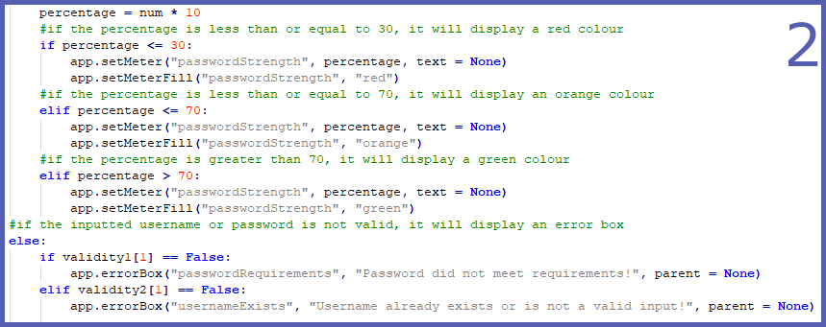

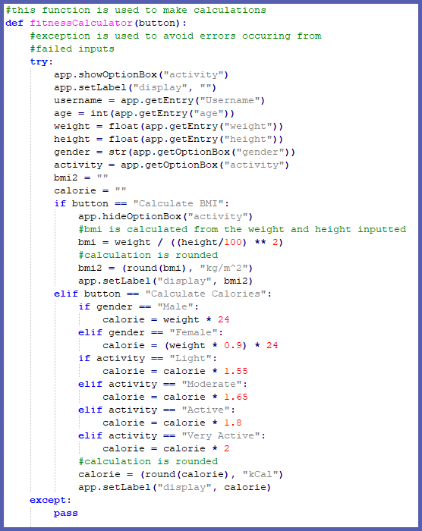

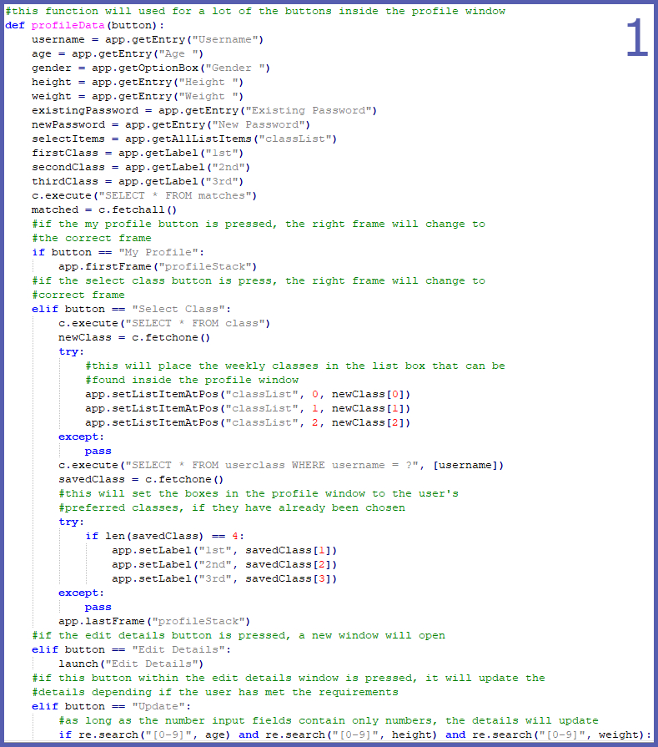

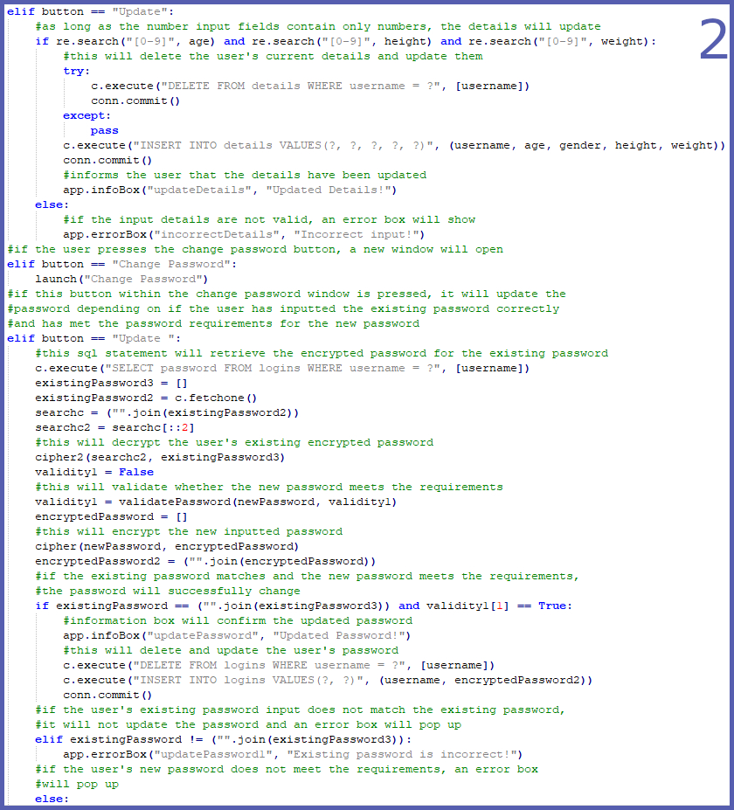

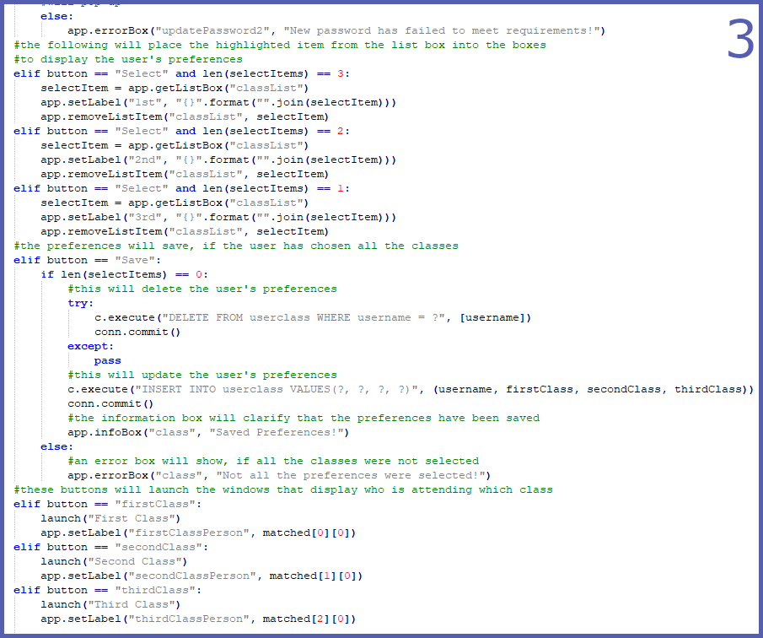

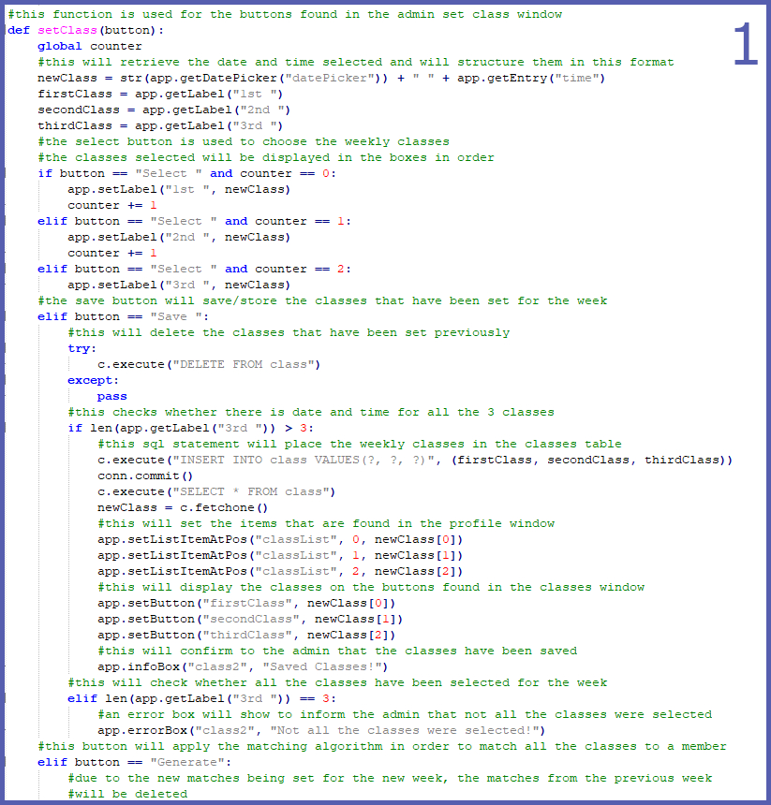

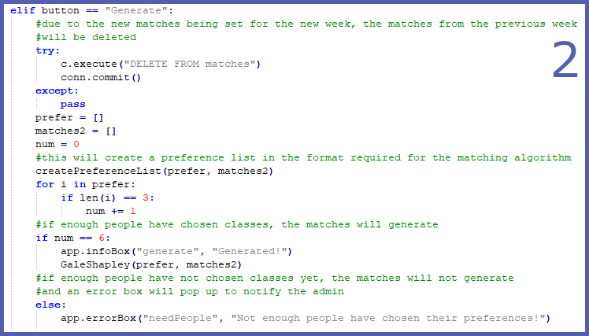

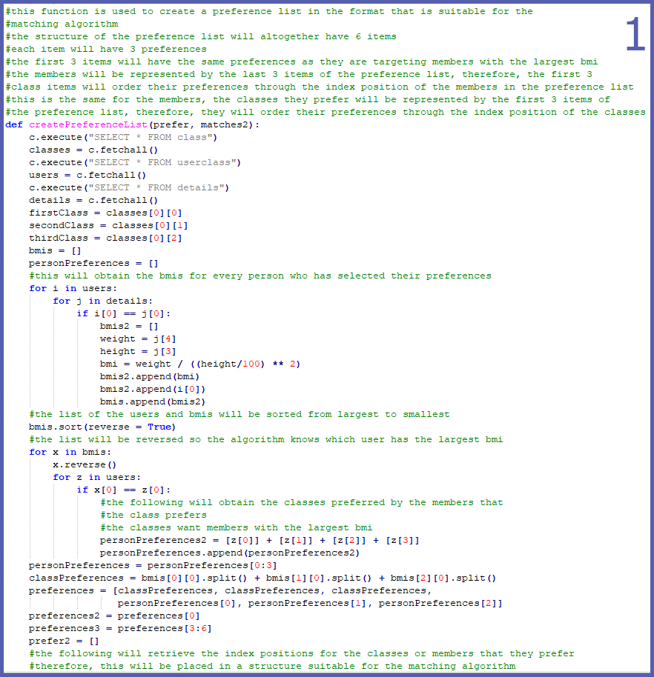

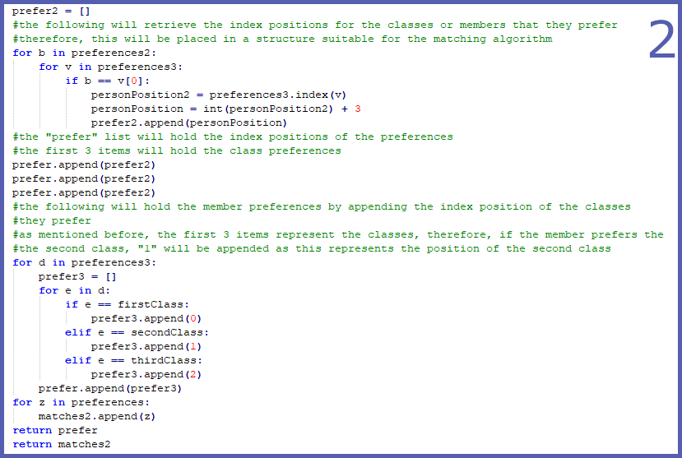

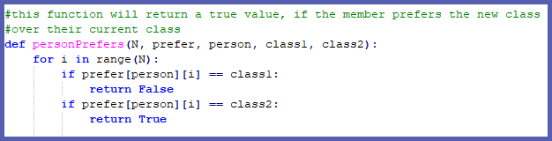

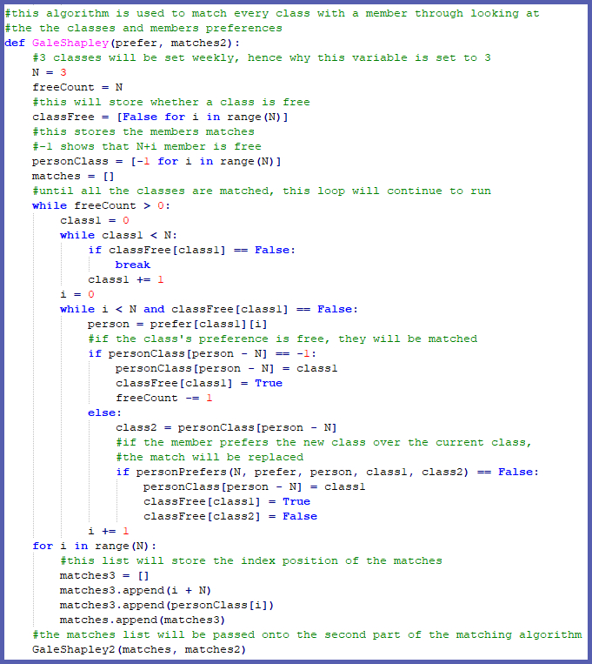

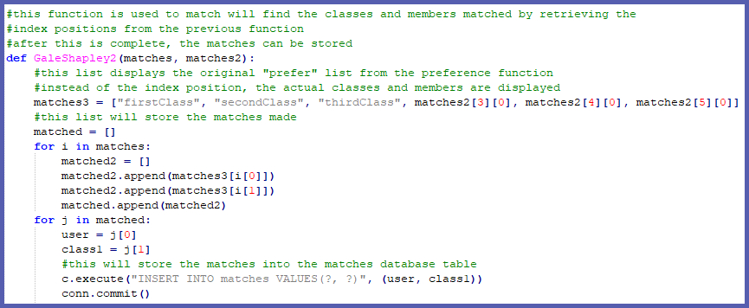

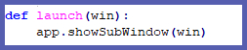

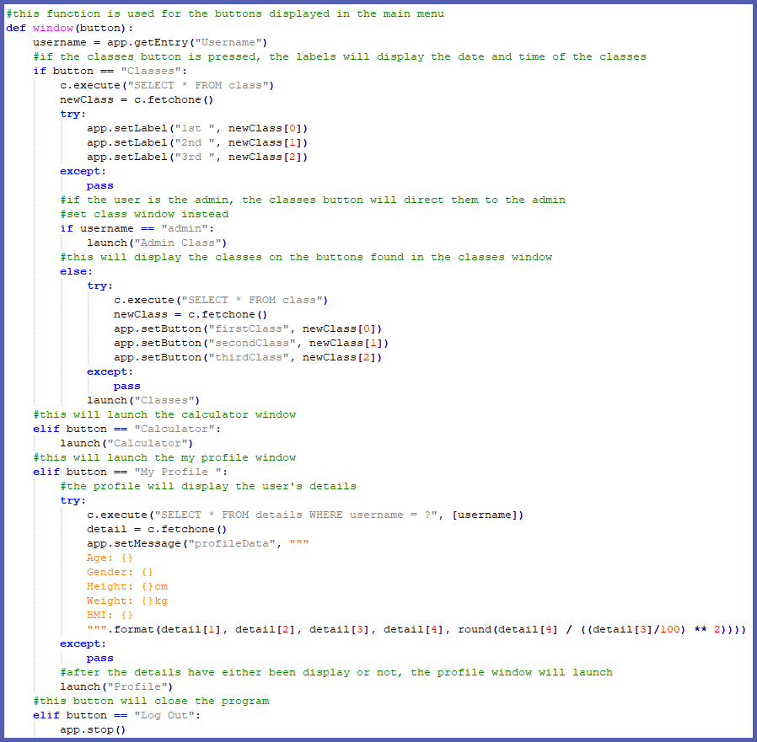

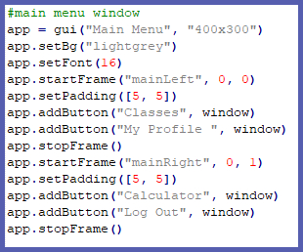

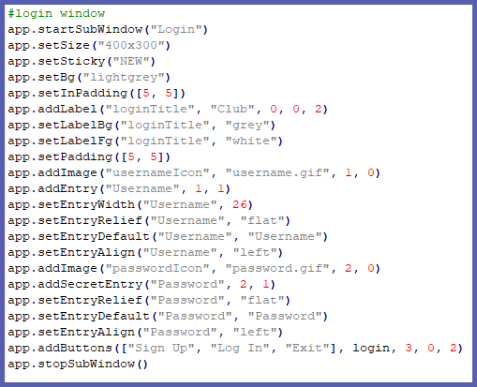

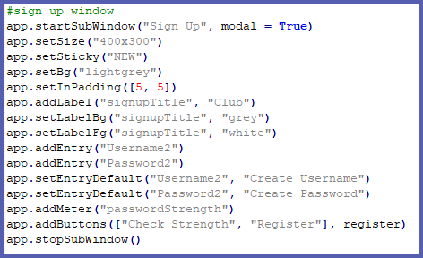

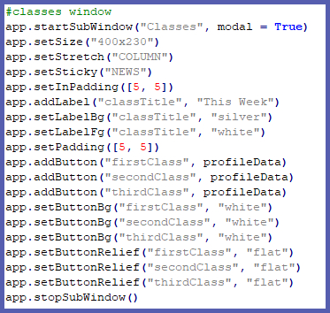

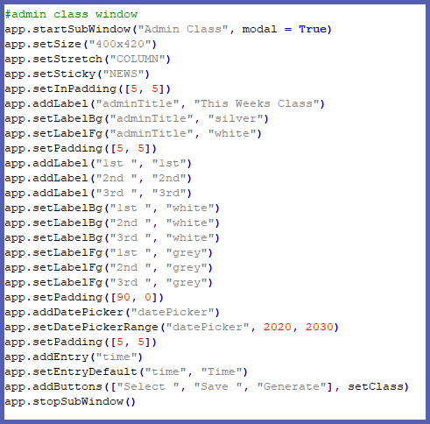

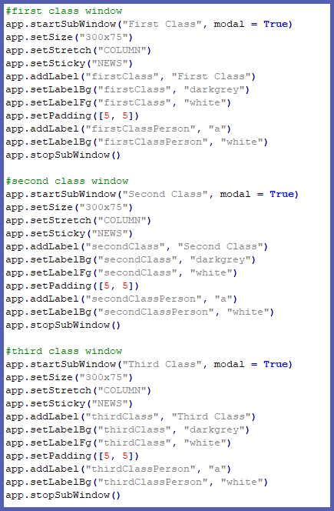

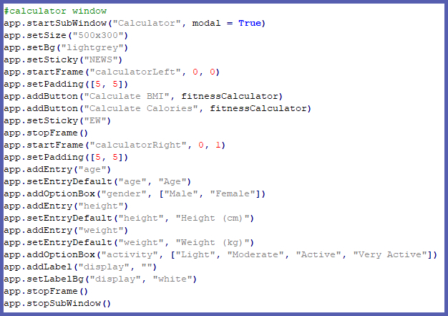

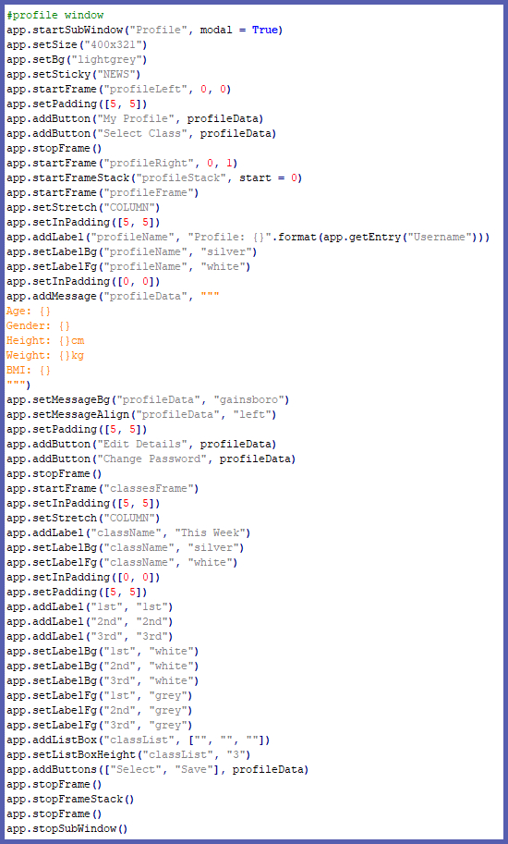

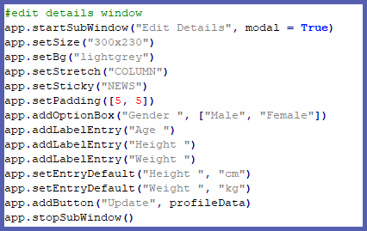

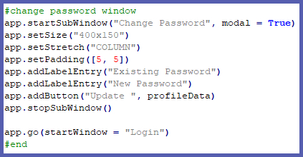

# **Evaluation**

## Were the objectives met?

|  |  |  |
| --- | --- | --- |
| **Objective** | **Met?** | **Comment** |
| 1 Create a login system | Yes | This objective has been met effectively as the program starts up an easy login system. |
| 1.1 Create a cipher algorithm to encrypt the password | Yes | This objective has been met effectively as the cipher I made changes the original string significantly. However, this could have been improved if I implemented a hashing algorithm to create a complex encrypted password. |
| 1.1.1 Store the encrypted password using SQL | Yes | This objective has been met effectively as I used SQL to store the encrypted password in the login database table. |
| 1.2 Provide an option to register | Yes | This objective has been met effectively as there is a register button on the login window. This directs the user to a register window. |
| 1.2.1 Display the requirements for the password | Yes | This objective has been met effectively as an information box pops up before the register window opens. |
| 1.2.2 Create a check which prevents duplicate usernames | Yes | This objective has been met effectively as the program prevents a user from registering, if the username already exists. |
| 1.2.3 Create a check which makes sure the password follows the requirements | Yes | This objective has been met effectively as the program prevents a user from registering, if the password does not meet the requirements. |
| 1.2.4 Allow the user to see if their password is strong | Yes | This objective has been met effectively as there is a check strength button in the register window. |
| 1.3 Provide an option to exit | Yes | This objective has been met effectively as there is an exit button in the log in window. |
| 1.4 Make sure the user can log in with the correct details | Yes | This objective has been met effectively as the user can only log in with valid details. The username and password are checked through the login database table to ensure that the details are correct. |
| 1.4.1 Check the SQL table to see if the username inputted is valid | Yes | This objective has been met effectively as there is a function to see if a username is valid. |
| 1.4.2 Use the cipher algorithm to encrypt the inputted password | Yes | This objective has been met effectively as the cipher algorithm can encrypt any string, especially passwords. |
| 1.4.2.1 Allow the user to continue to the main menu |  | This objective has been met effectively as the user can only access the main menu, if the details they inputted are correct. |
| 2 Create a main menu | Yes | This objective has been met effectively as the menu created holds the core functions of the program. |
| 2.1 Provides a classes option | Yes | This objective has been met effectively as the menu provides a classes button that leads to a classes window. |
| 2.1.1 Check if the user is an admin | Yes | This objective has been met effectively as the program will provide an option that is not available to the members. |
| 2.1.1.1 Give admin option to set up new classes for the following week | Yes | This objective has been met effectively as the admin set class window will show, if the admin clicks on the classes window. Within the admin set class window, the admin can use the select button to choose the classes for the week. However, this could be better if the admin can choose more than 3 classes a week. |
| 2.1.1.2 Allow the option to save the classes selected | Yes | This objective has been met effectively as there is a save button available which allows the classes to be saved/stored on a classes database table. |
| 2.1.1.3 Allow an option to choose who is selected for the classes through implementing the stable marriage algorithm | Yes | This objective has been met effectively as there is a generate button available which implements the stable marriage matching algorithm to all the members that have chosen their preferences. Once the matches have been made, they will be stored on a matches database table. |
| 2.1.2 Check if the user is not the admin | Yes | This objective has been met effectively as the classes window will display, if the user is not an admin. |
| 2.1.2.1 Display the classes for the following week | Yes | This objective has been met effectively as the classes window will display the classes set by the admin. |
| 2.1.2.1.1 Allow the user to click on the classes to see who is attending | Yes | This objective has been met effectively as a new window will show, if the user clicks on one of the classes. Within this new window, it will display the class and who is attending. |
| 2.2 Provide a calculator option | Yes | This objective has been met effectively as there is a calculator button in the main menu which lead the user to the calculator window. |
| 2.2.1 Allow the user to input age, gender, height, weight and activity rate | Yes | This objective has been met effectively as the user has the option to input their information. |
| 2.2.1.1 Allow the user to calculate their BMI | Yes | This objective has been met effectively as the user can press the calculate BMI button to make a calculation, if the input fields have been filled in. |
| 2.2.1.2 Allow the user to calculate their maintenance calories | Yes | This objective has been met effectively as the user can press the calculate calories button to make a calculation, if the input fields have been filled in. |
| 2.3 Provide a profile option | Yes | This objective has been met effectively as the menu provides a profile button that leads to a profile window. |
| 2.3.1 Display the username | Yes | This objective has been met effectively as the profile window displays the user’s username. |
| 2.3.2 Display the user’s details | Yes | This objective has been met effectively as the user’s details is displayed, under the user’s username, in the profile window. |
| 2.3.3 Allow the user to edit their details | Yes | This objective has been met effectively as there is an edit details button in the profile window which leads to an edit details window. |
| 2.3.3.1 Create a window which allows the user to update the details | Yes | This objective has been met effectively as the edit details window which shows up contains input fields which allow the user to make any updates. |
| 2.3.4 Allow the user to change their password | Yes | This objective has been met effectively as there is a change password button in the profile window which leads to a change password window. |
| 2.3.4.1 Create a window which allows the user to update their password | Yes | This objective has been met effectively as the change password window which shows up contains an existing password input field, a new password input field and an update button. |
| 2.3.4.2 Create a check to see if the user knows their current password | Yes | This objective has been met effectively as the user cannot update their password without knowing their current details. As a result, an error box will show up. |
| 2.3.4.3 Create a check to see if the new password meets the requirements | Yes | This objective has been met effectively as the user cannot update their password, without their new password meeting the requirements. As a result, an error box will show up. |
| 2.3.4.4 Allow the password to update if all the requirements are met | Yes | This objective has been met effectively as the user’s password will update, if the requirements in the change password window are met. |
| 2.3.5 Allow the user to select their preferred classes | Yes | This objective has been met effectively as the user can use the profile window to choose which classes they prefer. |
| 2.3.5.1 Display all the classes of the week | Yes | This objective has been met effectively as the profile window displays the classes that have been set by the admin. |
| 2.3.5.2 Allow a select option | Yes | This objective has been met effectively as there is a select button in the profile window which allows the user to choose their preferences. |
| 2.3.5.3 Allow a save option | Yes | This objective has been met effectively as there is a save button in the profile window which allows the user to save the preferences they have made. This is then stored in a user class database table. |
| 2.4 Provide a log out option | Yes | This objective has been met effectively as there is a log out button in the main menu which allows the program to exit. |
| 3 Create SQL tables | Yes | This objective has been met effectively as there is another python file connected to the main python file which has several different created tables. |
| 3.1 Create a login table that stores username and password | Yes | This objective has been met effectively as there is a login database table which stores username and password. |
| 3.2 Create a details table that stores the user’s details | Yes | This objective has been met effectively as there is a details database table that stores the user’s details. |
| 3.3 Create a class table which allows the admin to update the weekly classes | Yes | This objective has been met effectively as there is a class database table that stores the weekly classes. |
| 3.4 Create a user class table which stores user’s preferred classes | Yes | This objective has been met effectively as there is a user class database table that stores the user’s preferred classes. |
| 3.5 Create a match class table which stores the matches | Yes | This objective has been met effectively as there is a match class database table that stores the matches made by the admin when implemented the stable marriage matching algorithm. |

## Feedback from the End User

**Do you think this system has solved many of your problems?**

The system has solved many issues that I had with my previous system. Firstly, I faced a lot of pressure when dealing with class requests as I felt that I had to respond instantly. This problem has now been resolved as this new system eliminates me having to communicate back and forth with the club members. Secondly, it was difficult for me to balance managing classes and running them. Therefore, introducing this new system of applying the matching algorithm can help me to set the classes at the end of week rather setting them up throughout the week. This also improves how my timetable works as I can now plan, thus, I have more time during the day. Finally, I will not have to constantly write down everyone’s details more than once as it is now stored.

**Are there any improvements that could have been made?**

It would have been better if I had the option to pick how many classes can occur throughout the week rather than have it fixed at 3. In addition, it would be better if I had more options as the admin. More specifically, it would have been convenient if I was able to manage the members and store notes about them as this would help me to monitor their achievements and targets.

**Do you think the structure of the program is easy to use?**

Yes, it was very simple for me to navigate throughout the program as everything is self-explanatory. I had no issues with figuring out how the program works.

**Are there any issues with the program?**

No errors had occurred, everything works the way it should.

## Improvements

Generally, this program has been created well as it had met all the objectives as well as solve problems the end user was facing. The end user had to spend a lot of time organising the classes, therefore, the solution created had eliminated this issue by allowing the end user to set the classes with a simple button once every week. Despite doing so, there could have been improvements by adding more features for the admin. This would allow the admin to have more control and management over the members of the club. Specifically, it would be better if I had an option where the admin could monitor the members by writing down notes about them as well as be able to delete their account if the admin wishes to.

If this problem was to be revisited, the outcome could have been improved. Regardless of the success I had with creating this solution, it would have been even better if I added the features mentioned as well use another programming language to make it. This would allow the program to run on different platforms, especially on a phone which would provide the end user with more portability.